**RCNN – Object Detection 2014**

**SVM Classification**

**How RCNN works?**

**Original data 🡪 Selective Search 🡪Bounding box🡪CNN**

**Bounding Box Regression**

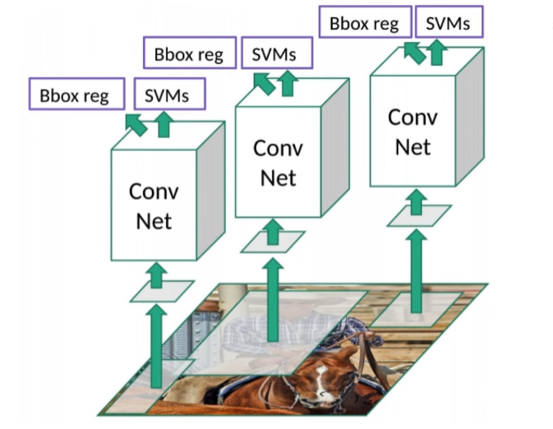

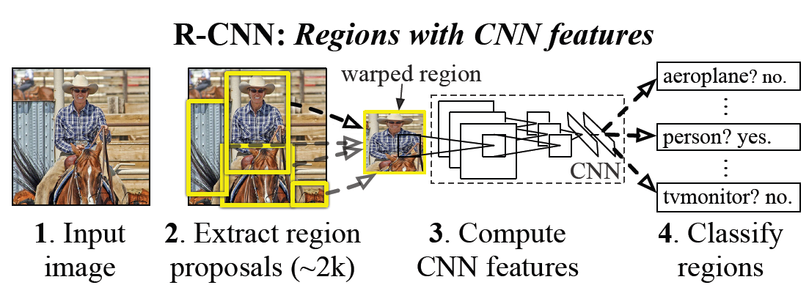

**Time Consuming:**

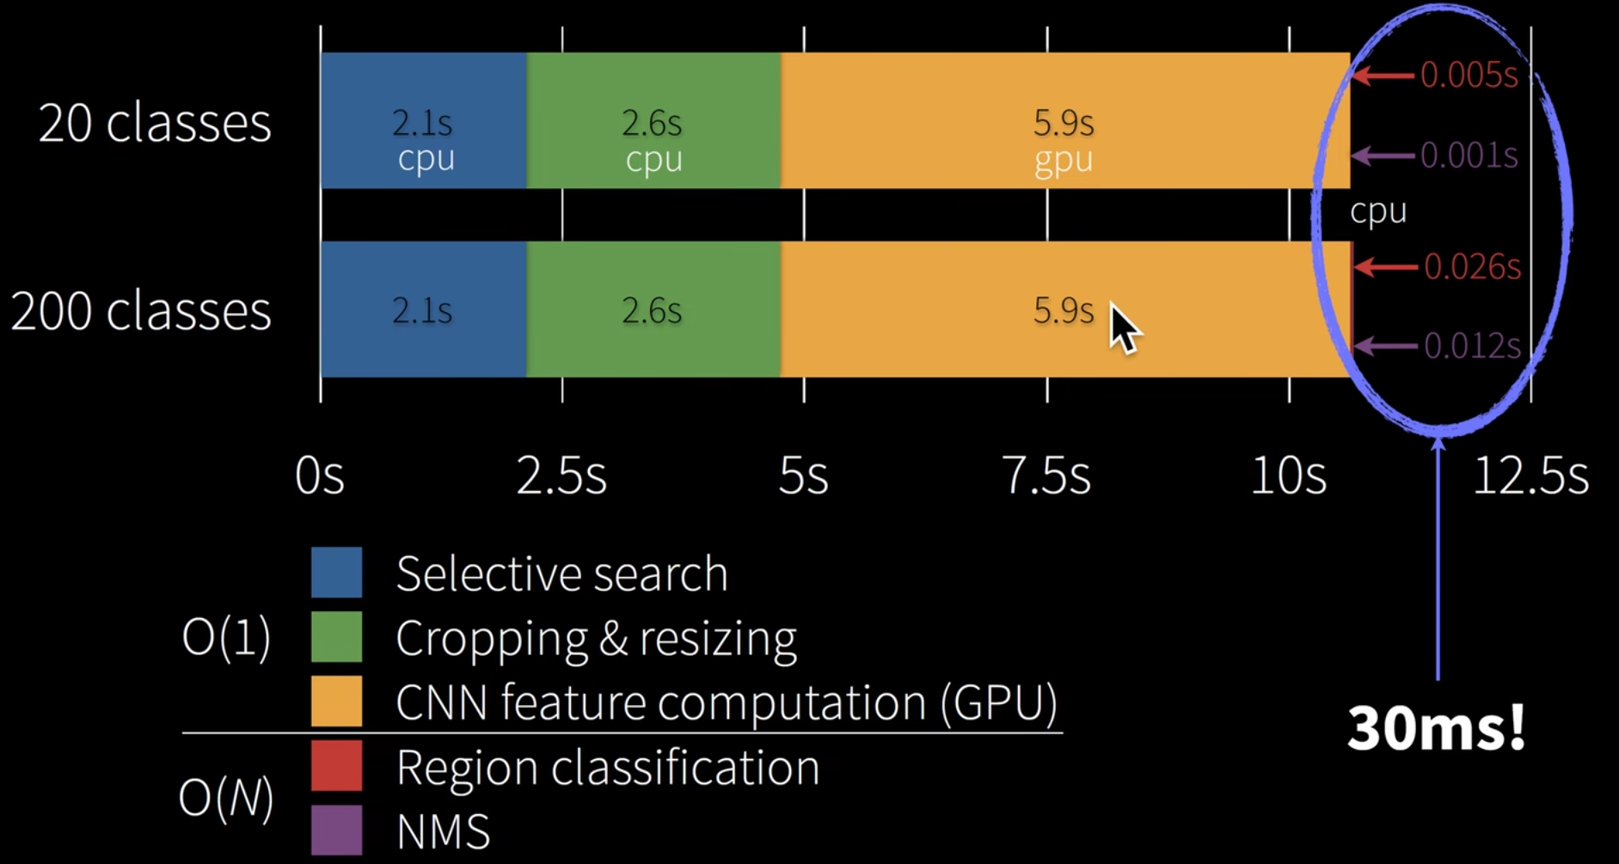

Selective Search:



